Guide to bands visiting Highweek Parish Church

The following information is to assist visiting ringers who are coming to Highweek parish Church.

The Church is situated Highweek Village which is on the North side of Newton Abbot.

The Church is accessed by a fairly narrow lane which leads to a fairly large parking area immediately outside the Church. There is no charge for parking. Whilst it is possible to get coaches directly outside the church its a tight squeeze and the area is used by dog walkers and others which can sometimes restrict parking and turning.

In addition, the A382 Drumbridges to Newton Abbot Road is now closed so access is via Ashburton Road Newton Abbot. If you are coming via Drumbridges then Diversions are signposted, you are best taking the Western route which will take you past Bickington and join the Ashburton Road near Caton Cross.

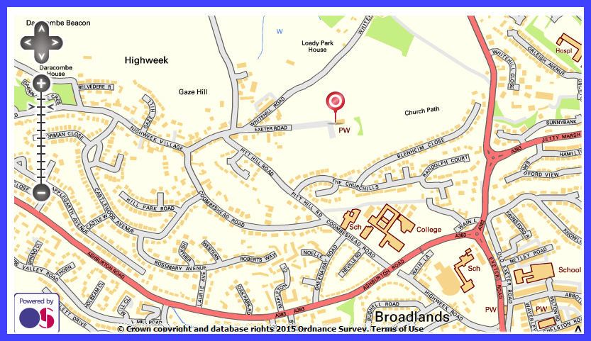

Within the Church there is a toilet.

The bells are rung from a gallery area which is accessed by a small flight of stairs. There are no clock hammers of clock chimes to worry about.

The bells and fittings are in good order and the bells themselves go well, please feel free to adjust the ropes to suit

For Peals we have a fee of £5.00 a rope and £1.50 a rope for quarters, visiting bands we would ask to leave an appropriate donation.

Local facilities

Within the village is the Highweek Inn, which is just down from the Cross roads where you turn in. This pub does very good well-kept beer and cheap food, good old fashioned pub grub, they have a room at the back which can cater for a reasonable size group. They are always very accommodating. The pub has a large car park.

If you have any other questions or queries then give me a ring

Robert Brown

07837267633
robert@robertbrown.me.uk

